THE CREATIVE TESTS – QUESTIONS
for the graduates of specialty 7M07301 – «Architecture»

76. Determine the basic materials of "Pop Art" style
a) Using of ultramodern and new materials
b) Using of only wood and glass
c) Using of unusual materials or old, used, broken things. For interior decoration sometimes used unusual materials such as painted shells, glass bottles, pieces of porcelain, mirror, glass
d) а + b + c
e) All answers are wrong

77. Determine the “Pop Art” style on the following pictures
а)  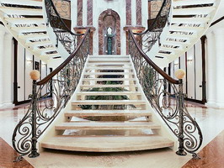 | b) 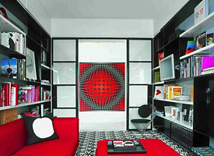 | c)  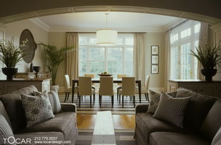
d)  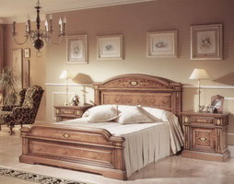 | e) All answers are wrong

78. Determine the basic materials of “Techno” and “High-tech” style
a) glass and metal construction
b) colored plastic and quite a bit of wood
c) only wood
d) а + b + c
e) All answers are wrong

79. Determine the “High Tech” style on the following pictures
а)  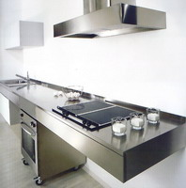 | b) 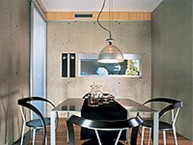 | c)  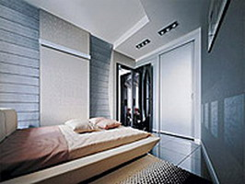
d) а + b + c | e) All answers are wrong

80. Determine the color spectrum of “High Tech” style
a) Red, yellow, blue
b) Metallic, silver, white, black;
c) Brown and Gold
d) а + b + c
e) All answers are wrong

81. Determine the color spectrum of “Kitch” style
a) Hot pink, poison-green, purple, aggressive red and gold, white and black.
b) Metallic, silver, white, black;
c) Beige, brown and gold
d) а + b + c
e) All answers are wrong

82. Define the famous architect and designer who developed the “Loft” style
a) Andy Warhol
b) Antonio Gaudi
c) V.M. Polanski
d) а + b + c
e) All answers are wrong

83. What is the aesthetics of "Futurism" style?
a) a return to the origins of classicism
b) to shock
c) on the rejection of the order system
d) а + b + c
e) All answers are wrong

84. Determine the “Futurism” style on the following pictures
а)  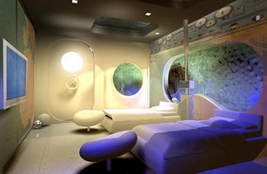 | b) | c)
d) a + b + c | e) All answers are wrong

85. Where the “Avant-garde” style was born?
a) in America
b) in Italy
c) in Russia
d) а + b + c
e) All answers are wrong

86. What features “Avant-garde” style has?
a) Beauty, decorative and grace of forms
b) Practicality, functionality, emphasized graphically and laconic lines, abundance of clear and precise geometric shapes, a minimum of parts, lots of glass, metal and plastic, using of the most modern materials.
c) The main idea of ​​the style - mockery of history and artistic traditions, tastes and styles. Using in compatible colors and objects of the interior.
d) а + b + c
e) All answers are wrong

87. Determine the “Loft” style
a) Practicality, functionality, emphasized graphically and laconic lines, abundance of clear and precise geometric shapes, a minimum of parts
b) The process of transforming of the old brick warehouses, factories and schools in homes without interior walls, with plenty of air, where there is no division into separate rooms, only zones with different appointment.
c) Beauty, decorative and grace of forms
d) а + b + c
e) All answers are wrong

88. Name the style which concerns with the "modern" style in France.
a) Art - Nuovo
b) Jugendstil
c) Liberty
d) а + b + c
e) All answers are wrong

89. Name the style which concerns with the "modern" style in Italy.
a) Art - Nuovo
b) Jugendstil
c) Liberty
d) а + b + c
e) All answers are wrong

90. Name the style which concerns with the "modern" style in Germany.
a) Art - Nuovo
b) Jugendstil
c) Liberty
d) а + b + c
e) All answers are wrong

91. Buildings and interiors of what style didn’t exist in Russia in 90 - years of the ХХ century
a) Decorative
b) Constructivism
c) Functionalism
d) а + b + c
e) All answers are wrong

92. What the German design school was founded in the 20-30-years "functionalism" style.
a) Bauhaus
b) Vkhutemas
c) Strogonovskoe School
d) а + b + c
e) All answers are wrong

93. Determine correct statement about "functionalism" style.
a) Complete denial of unnecessary decoration. The philosophy of style - form follows function
b) House - a machine for living
c) The interior is dominated by clear and concise form, a large role for the texture and the texture of the finishing materials.
d) а + b + c
e) All answers are wrong

94. Determine correct statement about "minimalism" style.
a) Complete rejection of the use of decorative
b) Monochromaticism, graphic, the abundance of free space.
c) The presence of only the most necessary furniture with simple circuits
d) а + b + c
e) All answers are wrong

95. What is the main instrument which create character and mood of the interior in the style of "minimalism"?
a) Light
b) Color
c) Closed space
d) а + b + c
e) All answers are wrong

96. Determine the “ Eclectic” style on the following pictures.
а)  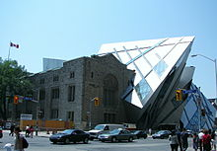 | b) 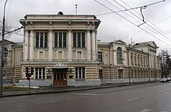 | c)  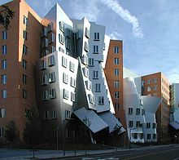
d) a + b + c | e) All answers are wrong

97. On the application in construction practice ideas what the French philosopher founded the direction of "deconstruction" in architecture
a) Zaha Hadid
b) Zh.Zhak Rousseau
c) Jacques Derrida
d) а + b + c
e) All answers are wrong

98. Determine the “Deconstruction” style on the following pictures.
а) | b) | c)
d) a + b | e) All answers are wrong

99. When the "deconstruction" was formed as an independent flow
a) in the late 1950's.
b) in the late 1980's.
c) in the early 1980's.
d) а + b + c
e) All answers are wrong

100. What architectural buildings considered manifestos flow "deconstruction"
a) firehouse "Vitra" by Zaha Hadid (1993)
b) Guggenheim museum in Bilbao by Frank Gehry (1997)
c) Austin Powers Museum in Bilbao by Frank Gehry (1987).
d) а + b + c
e) All answers are wrong

